Course ___Methods_Test 3_ Year __12_______

Student name: ________________ Teacher name: ________________

Date: Monday 3 August

Task type: Response

Time allowed for this task: _____45______ mins

Number of questions: _____9______

Materials required: Calculator with CAS capability (to be provided by the student)

Standard items: Pens (blue/black preferred), pencils (including coloured), sharpener, correction fluid/tape, eraser, ruler, highlighters

Special items: Drawing instruments, templates, notes on one unfolded sheet of
A4 paper, and up to three calculators approved for use in the WACE examinations

Marks available: __46____ marks

Task weighting: __10__%

Formula sheet provided: Yes

Note: All part questions worth more than 2 marks require working to obtain full marks.

Q1 (3.1.6) (3 & 3 = 6 marks)
Determine the exact gradient of each of the following at the given point. Show all working.
- at the point

- at the point

Q2 (3.1.6) (4 marks)
Determine the exact area shaded in the diagram below without the use of a classpad.
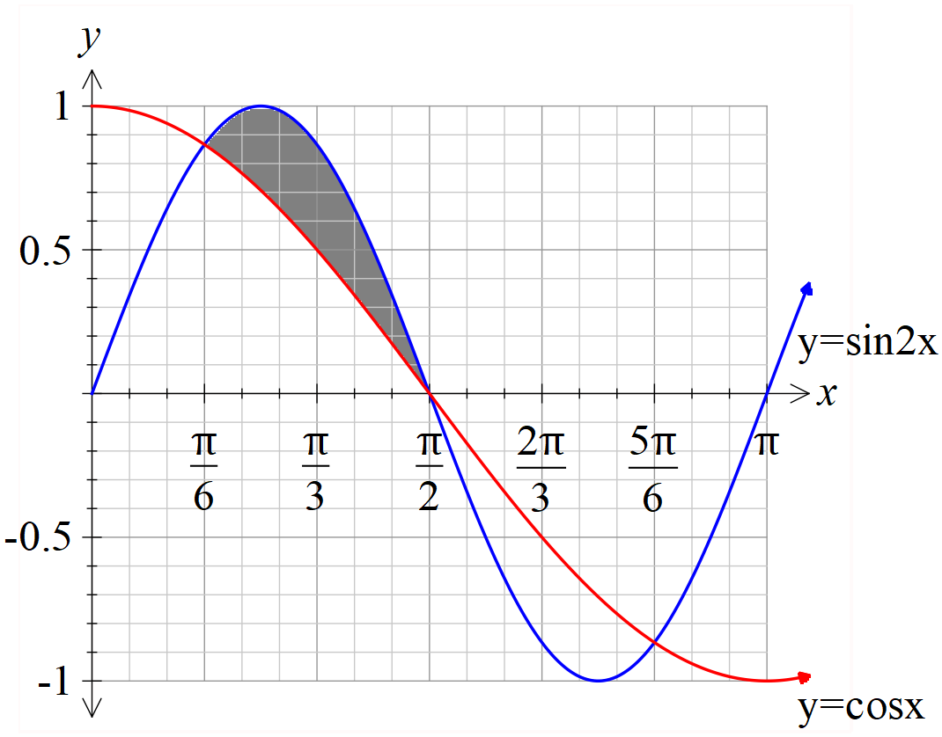

Q3 (3.1.6/3.1.10) (3 & 3 = 6 marks)
Consider the triangle drawn below with angle radians and fixed length sides 5 & 3 cm. Let represent the area of the triangle in .

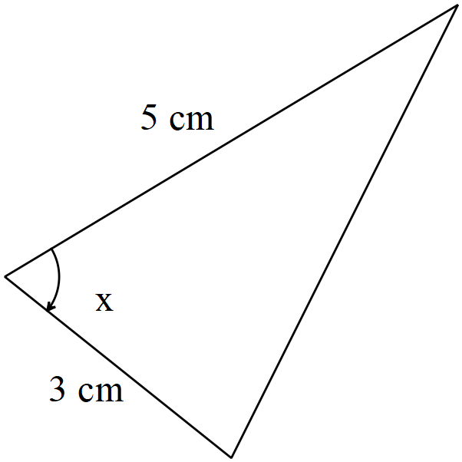
- Determine when .

- Using the increments formula, determine the approximate change in the area when the angle changes from to radians.

Q4 (3.3.1) (4 marks)
The expected value of the discrete probability distribution, given below, is . Determine the values of the constants and the variance of to 3 decimal places.
 | 1 | 2 | 3 | 4 | 5
 | 0.1 | P | 0.1 | q | 0.3

Q5 (3.3.13) (3 marks)
A binomial distribution has a mean of 6 and a standard deviation pf 1.9. Determine the values of , the number of trials and the probability of a success.

Q6 (3.3.7) (4 marks)
A teacher needs to scale the results of her class by first multiplying be a constant and then adding a second constant. The original mean was 72 with a standard deviation of 21, the teacher needs the scaled results to have a mean of 60 and a standard deviation of 15. Determine the values of .

Q7 (4.1.11) (3 & 3 = 6 marks)
The displacement of a car moving in straight line is given by km at hours, where .

The following questions require full working and answers only given by the classpad will not receive full marks.

- Determine the velocity at hours.

- Determine the time that the acceleration will be 0.2 .

Q8 (4.1.6) (3 & 3 = 6 marks)
Consider the function .
- Sketch the function on the axes below showing all major features.

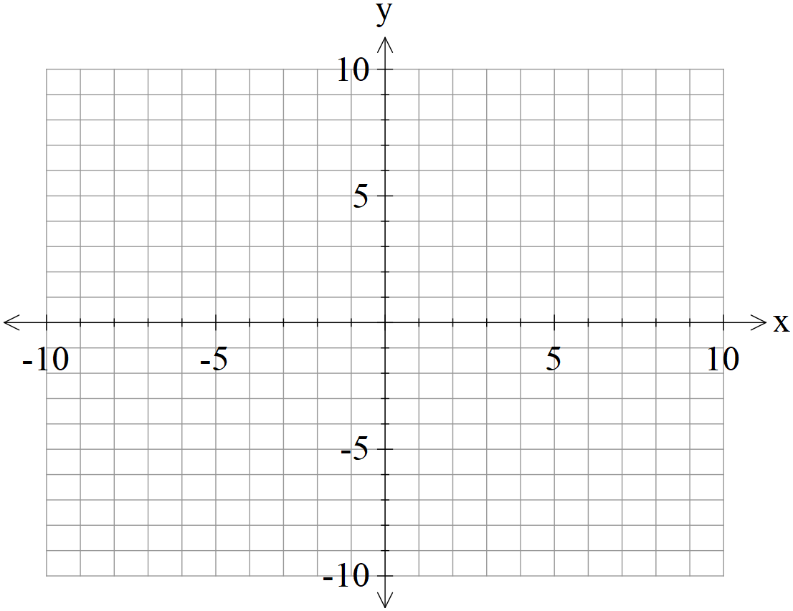

- In terms of the constants , determine the x intercept of the function .

Q9 (4.1.11/3.2.16) (3 & 4 = 7 marks)
This question must be answered without the use of a classpad to receive full marks.

- (Simplify)

- Use the result from (a) above to determine in exact simplified form.

